Oral or Poster
[Attention : 1 page maximum is required to submit your abstract.]

Main Title
[Main title style: Arial, size 14, bold, centered text, space after set to font size 10]

First Author,1* Second Author,2 Third Author1^{,2}
[Author list style: Arial, font size 11, centered text, line spacing: single. Presenter underlined, co-authors separated by commas. No initials or middle names]

¹ Affiliation first author
² Affiliation second author
[Institution list style: Arial, font size 10, italic, centered text, single line spacing]

*Corresponding Author: xxx@yyy.com
[Corresponding author’s email style: Arial, font size 10, centered text]

[Body text style: Arial, font size 11, justified alignment, single line spacing]
This document contains the instructions to prepare and submit your abstract for JE2026. The abstract should summarize the objectives, methodology, results, and conclusions of the work.
Page format: A4 (210 × 297 mm); margins: 20 mm on all sides, except the top margin; the paper title should start 25 mm from the top of the page. Once finalized, the abstract must be converted to PDF format and uploaded via: https://je2026.sciencesconf.org/

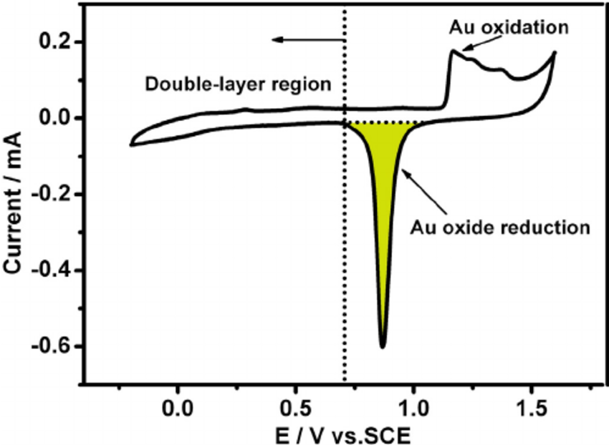
Figure 1. Figure caption, to be placed below the figure.
[Caption style: Arial, font size 10, centered text]

Table 1. Table caption, to be placed above the table.
[Table title style: Arial, font size 10, centered text]
Case | Data 1 (unit) | Data 2 (unit) | Data 3 (unit)
1
2
3

Acknowledgment
Use this section for the acknowledgment such as the supporting grants, etc.
[Acknowledgment style: Arial, font size 11, justified alignment, single line spacing]

References
1. G. Loget, D. Zigah, L. Bouffier, N. Sojic, A. Kuhn, Acc. Chem. Res. 2013, 46, 2513.
2. A. Singh, L. Ouassi, K. Allemang, J.F. Lemineur, O. Sel, F. Kanoufi, C. Laberty-Robert, J. Power Sources 2025, 625, 235585.
[Reference style: Arial, font size 10, justified alignment, single line spacing]

[Please, remove all format instructions before submitting the abstract]

